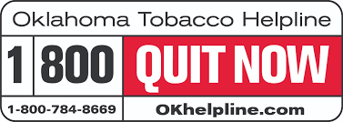

Oklahoma Tobacco Helpline Partner Toolkit – January 2022
The new year and Oklahoma Quit Week, January 19-26, make January a crucial month for Oklahomans thinking about quitting tobacco. Join the Oklahoma Tobacco Helpline and OK To Quit in encouraging Oklahomans to use FREE cessation services from the Helpline!

How to Use this Toolkit
1. Review developed materials below promoting the free services offered by the Oklahoma Tobacco Helpline and plan to post them in the weeks when Oklahomans are most likely to be thinking about quitting – around the new year and during Oklahoma Quit Week, January 19-26.
2. Download desired hi-res images from the link here.
3. When sharing posts on your social channels, feel free to use the messages and imagery from this toolkit, but also adapt any wording or style that better fits your audiences. Continue to use your brand voice.
4. Please tag the Helpline (@OKhelpline on Instagram and Twitter, @OklahomaTobaccoHelpline on Facebook) every time you use one of our posts. It makes it easier for your audience to connect with free cessation services from the Helpline.

Download Image Files Here

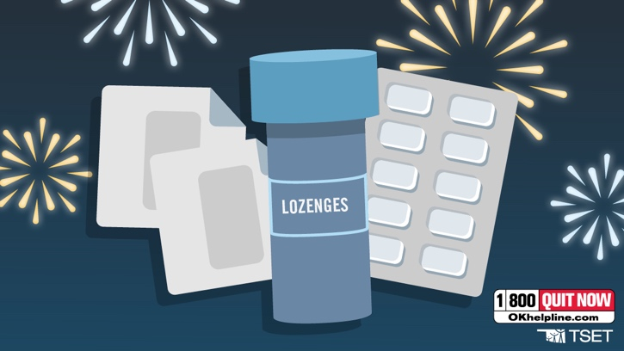
Resolved to make a positive change? The Oklahoma Tobacco Helpline has everything you need to get ready, including FREE patches, gum or lozenges — plus helpful tips and resources to beat cravings. Visit OKhelpline.com to learn more.

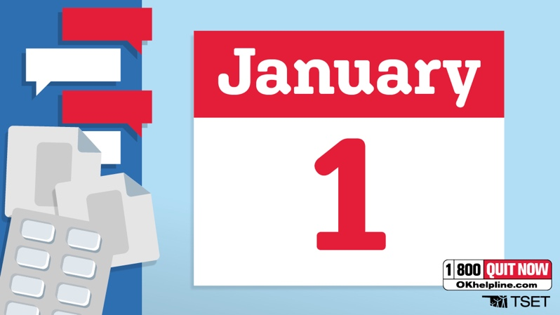
New Year’s is fast approaching. The Oklahoma Tobacco Helpline has FREE patches, gum or lozenges, Quit Coach support and so much more. Join a movement — and get trusted help to quit with the Helpline. Visit OKhelpline.com for more.

New year, new questions! What happens after you quit tobacco? Your lungs begin to heal almost immediately — and soon, you’ll be breathing much easier. Quit for FREE with the Oklahoma Tobacco Helpline. Learn more at OKhelpline.com.

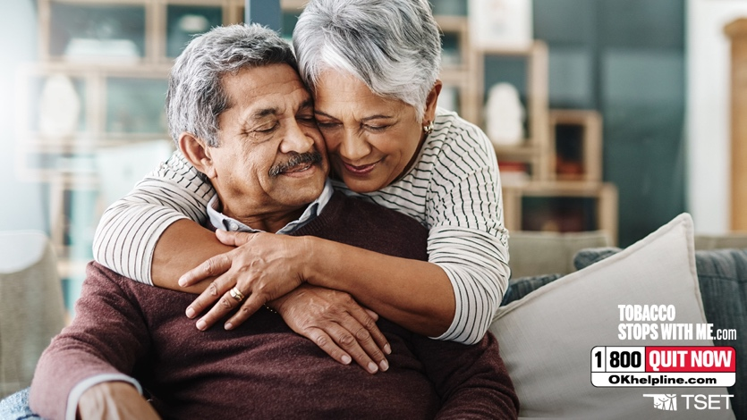
Conquer tobacco with help that works! Quit for FREE with the Oklahoma Tobacco Helpline. The best part? After just one year, your risk of heart disease drops by half, and continues to decrease over time. Visit OKhelpline.com for more.

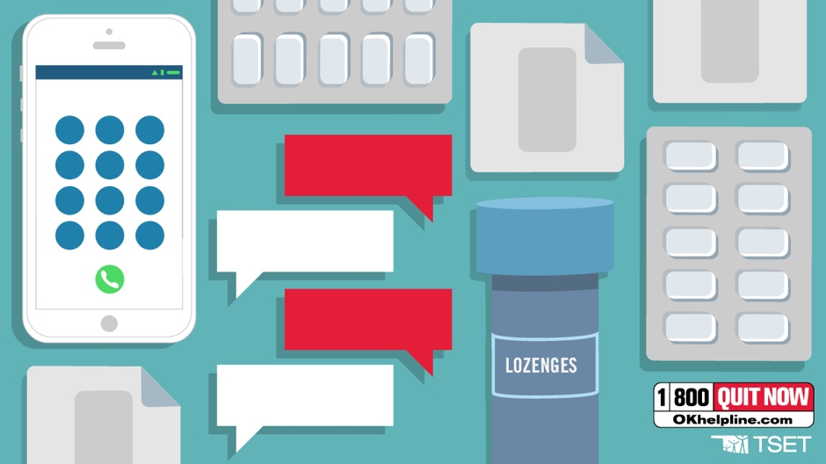
Gear up to quit tobacco! Click to see how the Oklahoma Tobacco Helpline supports your tobacco-free journey. The best part? The Helpline is always 100% FREE. Visit OKhelpline.com today!

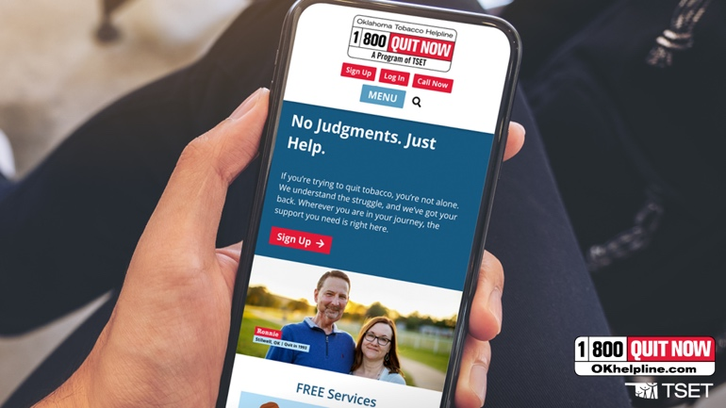
When it comes to quitting tobacco, you’re not alone! Get 100% FREE support to quit! The Oklahoma Tobacco Helpline has your back with patches, gum or lozenges, and so much more. Find support at OKhelpline.com.

Download Image Files Here

